Task 2

Kindly check the repository:

<https://github.com/Sakti-Sundar/assignment1-task2>

Added Collaborators

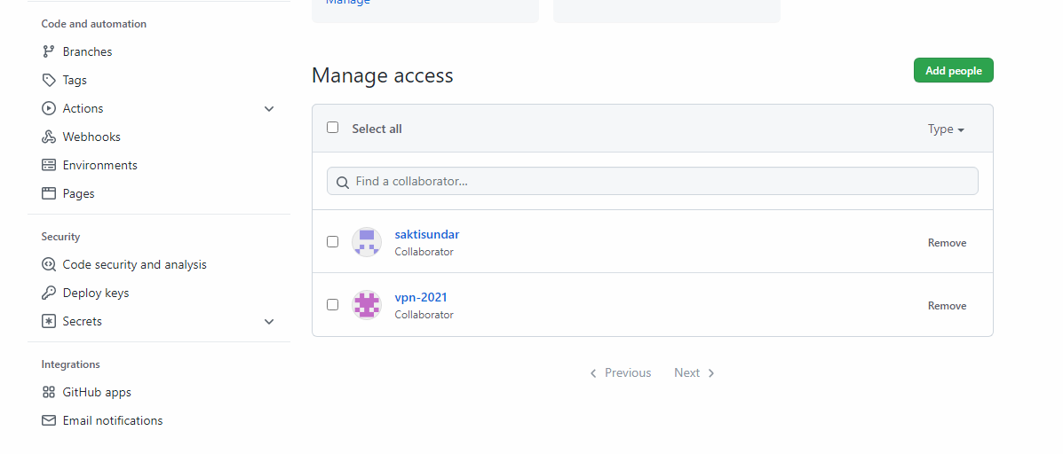

Github Pages Hosted

https://sakti-sundar.github.io/